**Nguyen Cong Thanh**

**SE130443-IA1301**

**HOD401**

**Project 5 :**

**Enumerating Metasploitable2**

**Task 1: Enumerating using nmap**

Find host and open port

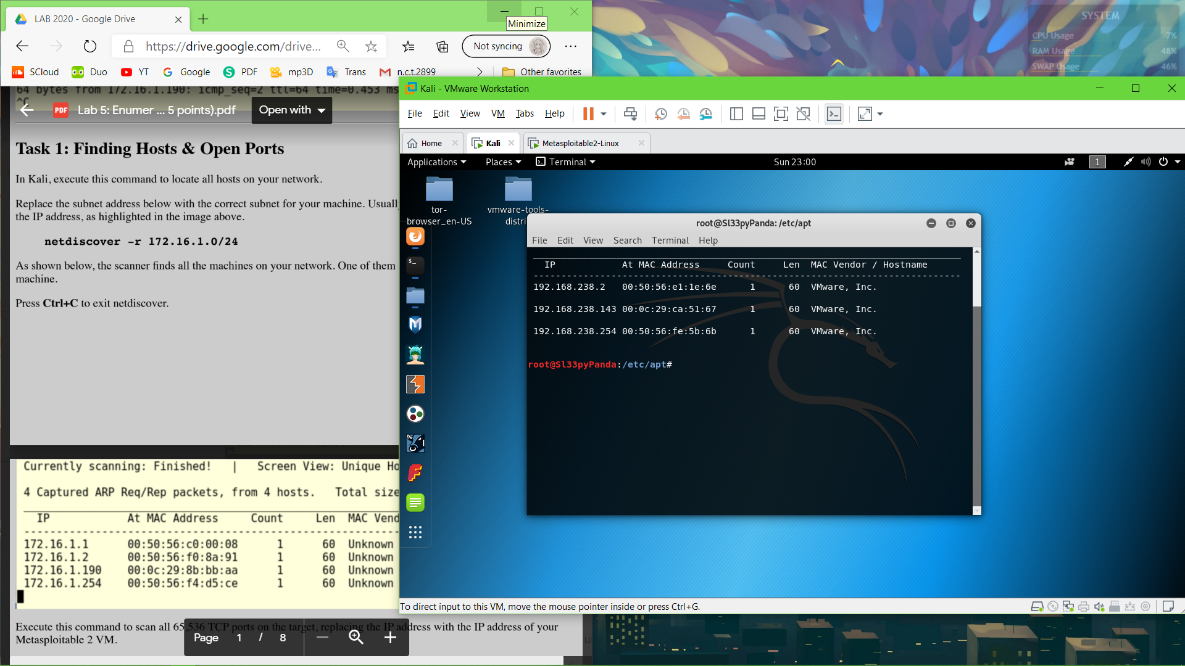

Scan for services

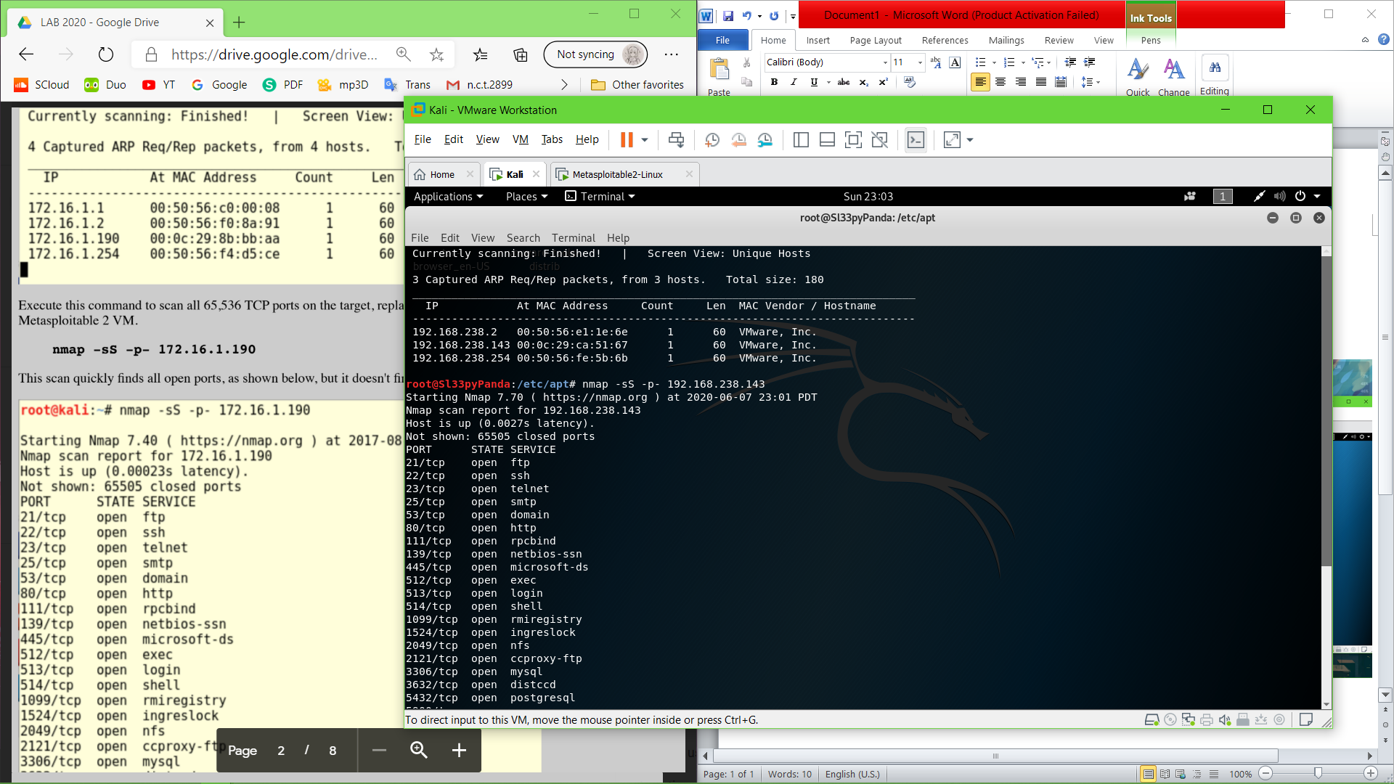

Scan for users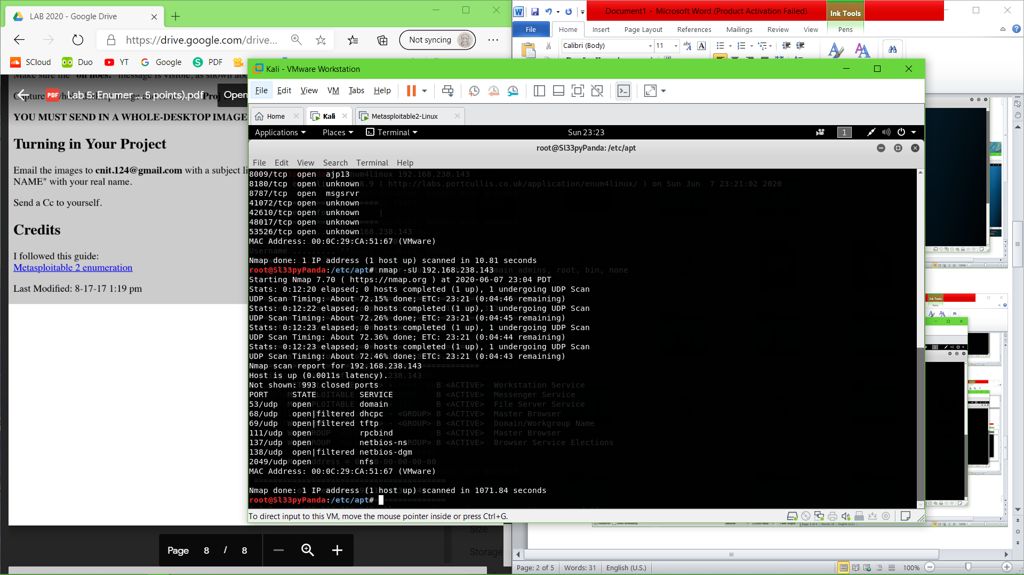

**Task 2: Enumerating Users**

Using Nmap –script

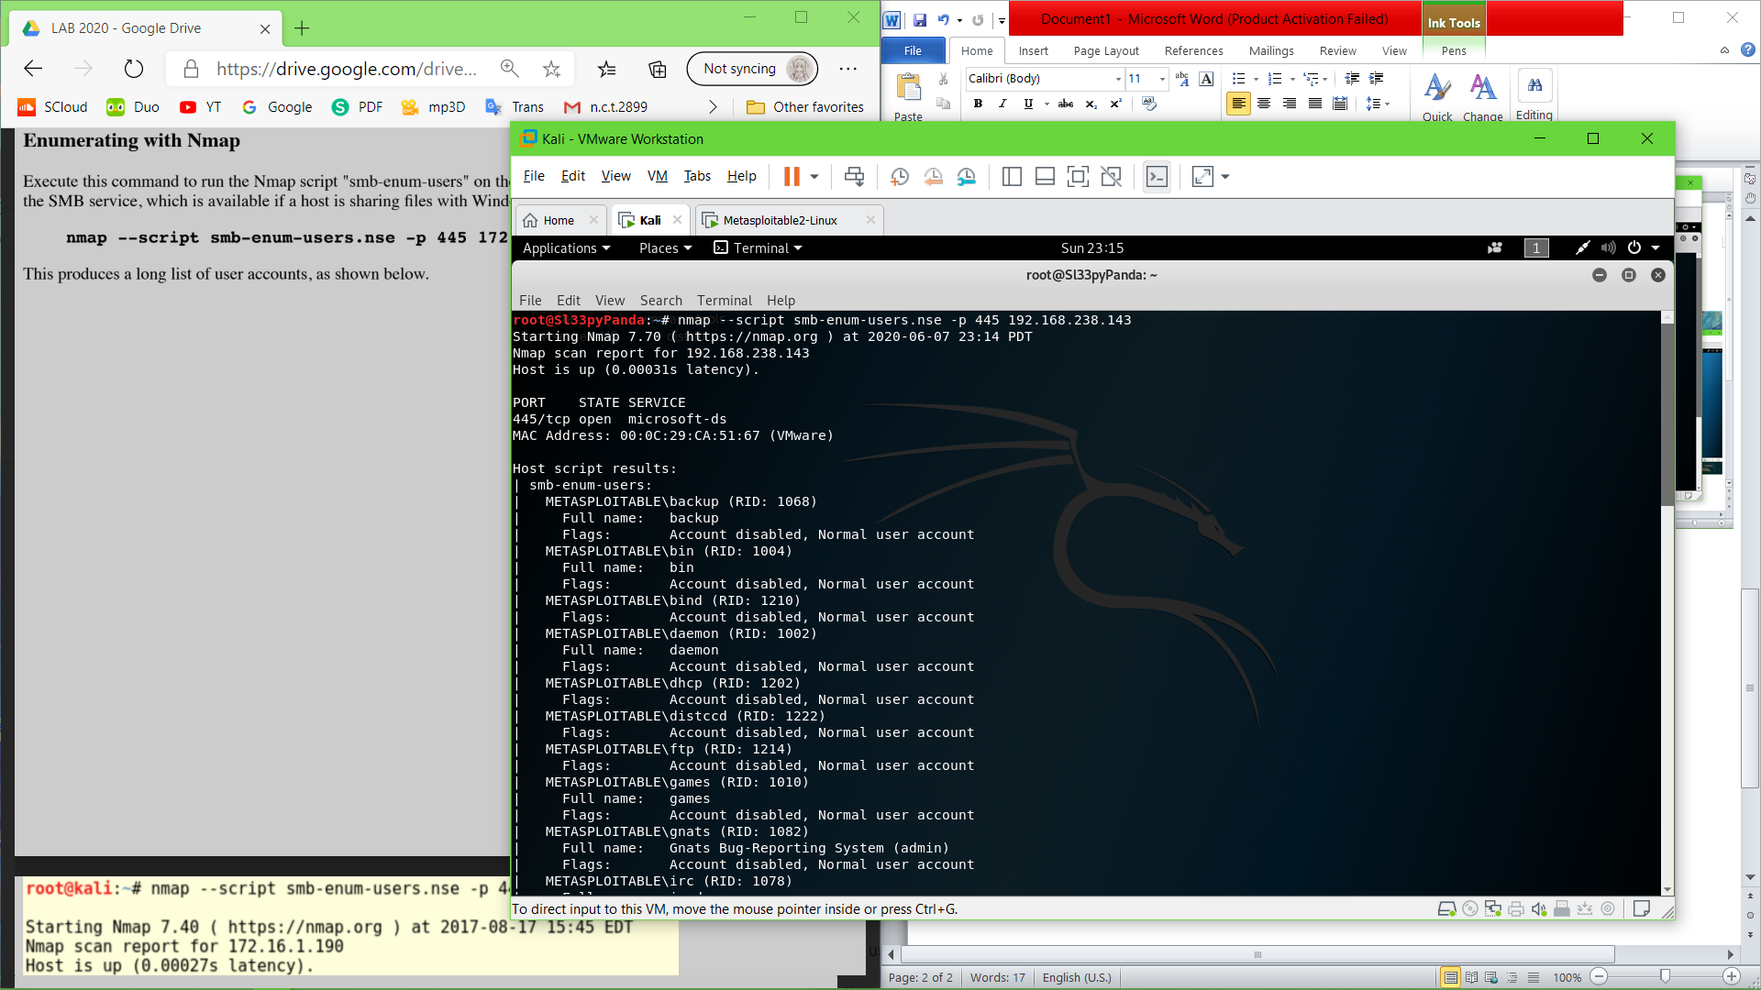

Rpcclient – U

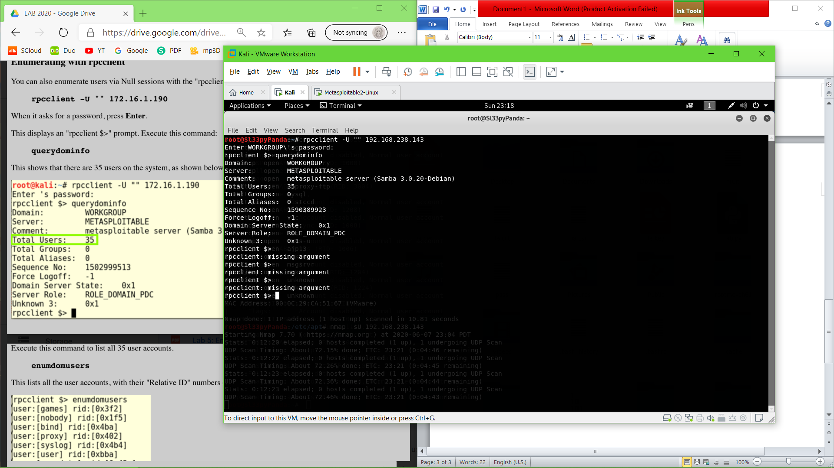

Enumdomusers

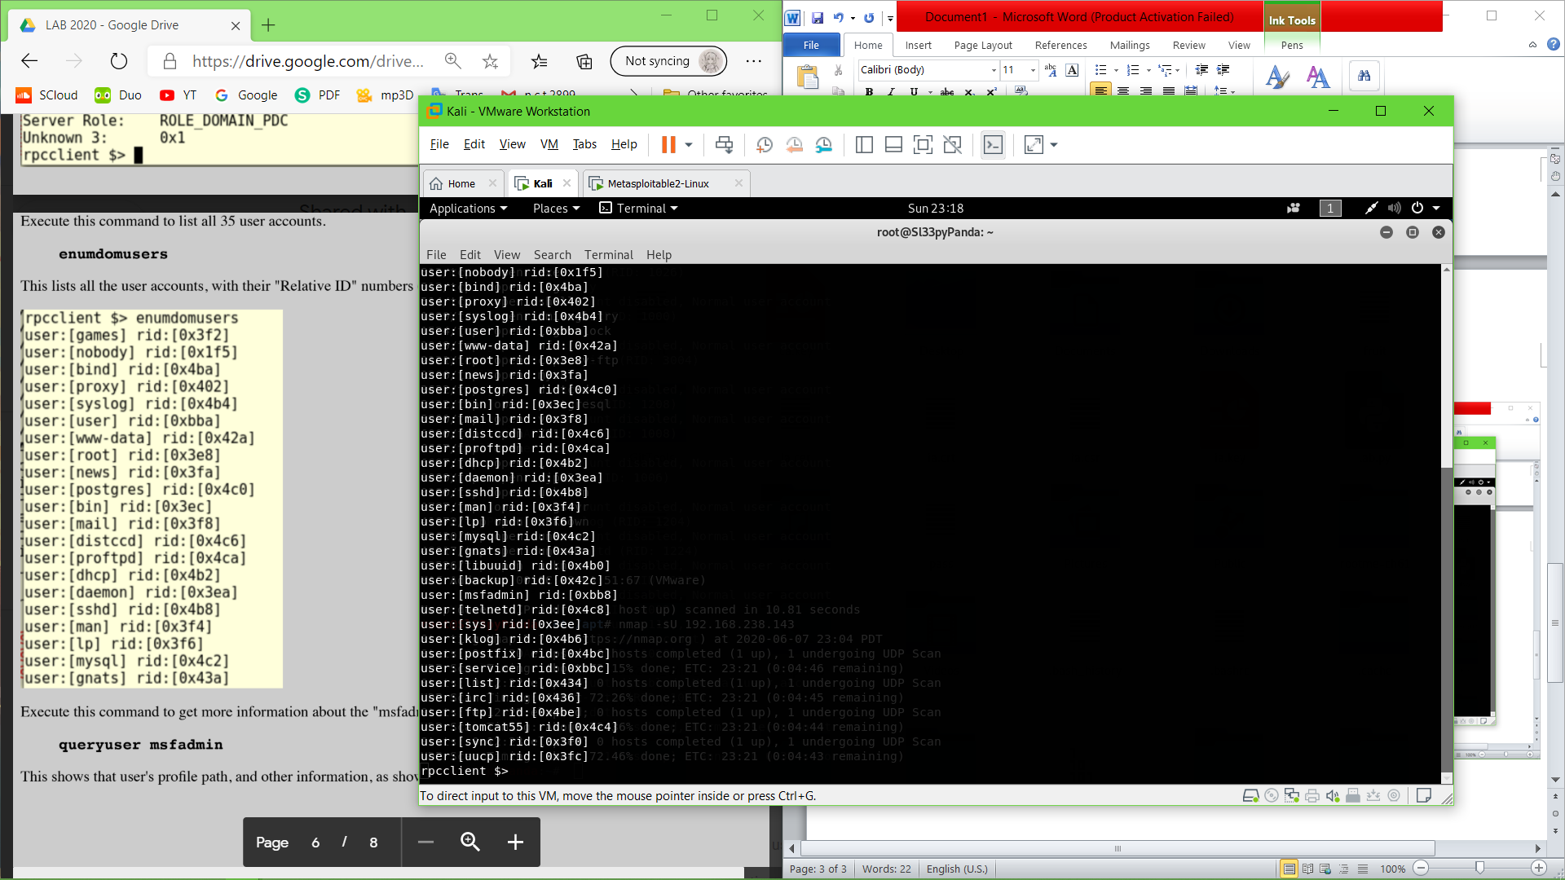

Queryuser mfsadmin

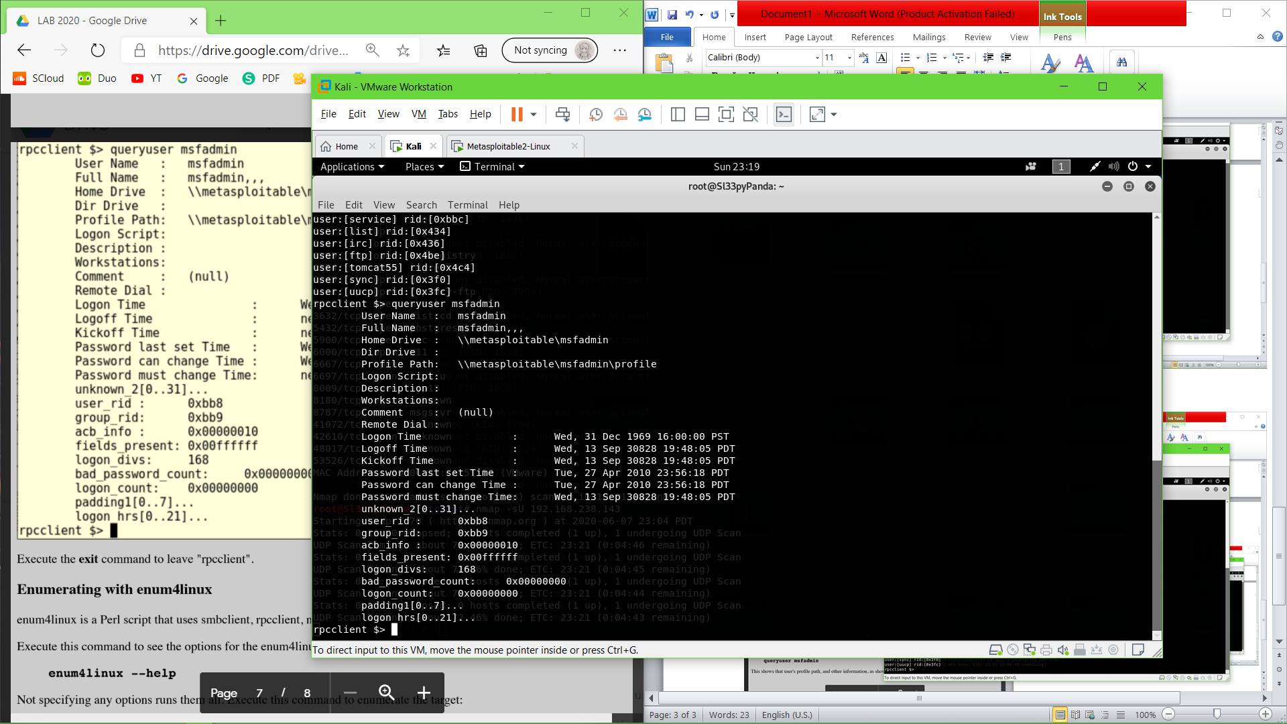

Enumerating with enum4linux

